**Bug Report**

|  |  |
| --- | --- |
| ID number | #1 |
| Bug Summary | The addition operation doesn’t work properly. |
| Reporter | Haykanush Grigoryan |
| Submit Date | 24/12/2021 |
| Platform | Windows |
| Operating System | Windows 7 |
| Browser | Chrome 96 |
| Severity | Critical |
| Priority | High |
| Status |  |
| Assigned to | Developer |
| Version | 4.0 |
| Environment | http://qwallity4.herokuapp.com/exercises |
| Component/tag | calculator |
| Screenshot/video | bellow |

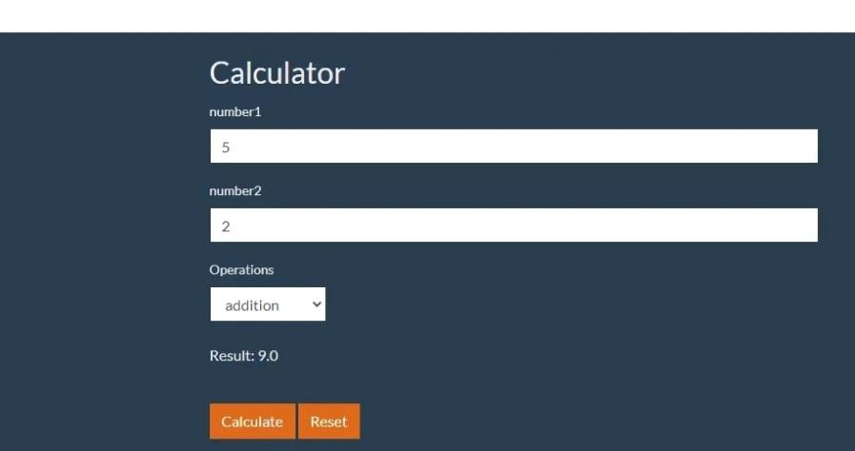

**Description:**

The addition function is not working properly.

**Steps to reproduce**

Step 1. Go to <https://qwallity4.herokuapp.com/>

Step 2. From navbar click Exercises button

Step 3. From the opened window press Calculator

Step 4. Input any number in the number 1 field

Step 5. Input any in number 2 field

Step 6. Choose addition from operations dropdown

Step 7. Press the Calculate button

**Expected result**

The Result of the addition function must be correct.

**Actual result**

In the Result the value of the addition is incorrect.